TNE20003 – Internet and Cybersecurity for Engineering Applications

**Portfolio Task – Lab 3 Pass Task**

Aims:

* To understand how arp works
* To investigate how MAC addresses are used and how the CAM table in a switch is populated.

Preparation:

* View “[Network Devices - Routers and Switches”](https://swinburne.instructure.com/courses/54168/pages/topic-3-network-devices-routers-and-switches-2?module_item_id=3692546)

Due Date:

* All tasks in this lab are to be completed and demonstrated to your Lab instructor preferably during or at the end of the current lab, but if you do not complete the tasks you may demonstrate it at the beginning of your next lab class.

Task 1.

Practice Subnetting

In this task, you will

* Subnet the given network (n/w) in the diagram below and allocate a subnet address to each relevant segment. •

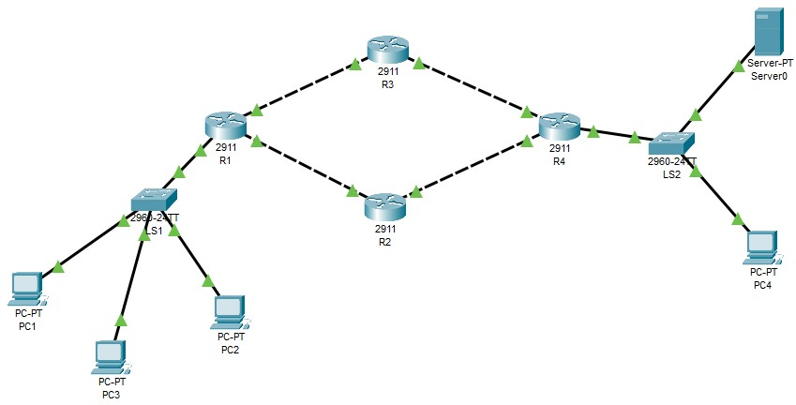

150.100.

1

20

.0

/

19

Figure 1

What is the subnetwork address of the IP given above????

R1 – LS1 150.100.96.0 /22

R1 – R2 150.100.100.0 /22

R1 – R3 150.100.104.0 /22

R2 – R4 150.100.108.0 /22

R3 – R4 150.100.112.0 /22

R4 – LS2 150.100.116.0 /22

How many n/ws do we need to build this n/w? 6

How many bits need to be borrowed? 3

What do the dotted lines connecting 2 routers mean? Non-data forwarding link

*of document*

Task 2.

**Build the network provided in task 1 with Cisco Packet Tracer and observe the building of ARP tables in the PCs and CAM table in the switch**

1. Implement the network shown in figure 1 above.

The bottom left hand corner of the Packet tracer screen displays the icons that represent device categories or groups, such as **Routers**, **Switches**, or **End Devices**.

Moving the cursor over the device categories will show the name of the category in the box. To select a device, first select the device category. When the device category is selected, the options within that category appear in the box next to the category listings. Select the device option that is required.

* 1. Select **End Devices** from the options in the bottom left-hand corner. Drag and drop 4 PCs and 1 Server onto your design area.
  2. Select **Switch** from the options in the bottom left-hand corner. Add 2 2960 switches to your prototype network by dragging them onto your design area.
  3. Select **Router** from the options in the bottom left-hand corner. Add 4 2911 routers to your prototype network by dragging them onto your design area
  4. Double click on each of the devices and name them as per the network diagram in figure 1.
  5. Select **Connections** from the bottom left-hand corner. Choose a copper straight-through cable type. Click the first PC (PC1) and assign the cable to the **FastEthernet0** connector. Click the switch (LS1) and select **FastEthernet0/1** to connect to PC1.
  6. Select **Connections** from the bottom left-hand corner. Choose a copper straight-through cable type. Click the second PC (PC2) and assign the cable to the **FastEthernet0** connector. Click LS1 and select **FastEthernet0/2** to connect to PC2.
  7. Select **Connections** from the bottom left-hand corner. Choose a copper straight-through cable type. Click the third PC (PC3) and assign the cable to the **FastEthernet0** connector. Click LS1 and select **FastEthernet0/3** to connect to PC3.
  8. Select **Connections** from the bottom left-hand corner. Choose a copper straight-through cable type. Click the switch (LS1) and select **FastEthernet0/4** to connect to **GigabitEthernet0/0/0** of Rtr1.
  9. Repeat these steps for all of the other devices until they are all connected as per the n/w diagram in figure 1. Note when connecting 2 routers together you need to use a cross-over cable because they are like devices, ie both are DTEs. Or you can use a serial cable.

There should be green dots at both ends of each cable connection after the network has converged. If not, double check the cable type selected. Note with the routers in particular, you may need to turn that interface on by clicking the **“on”** button under the interface tab or by issuing the command **“no shut”** on the interface in the CLI mode. See below:

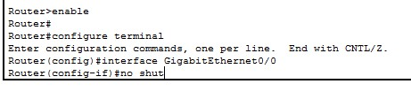

1. Configure Host names and IP Addresses on the PCs, the Server, the switches and the routers
   1. Click **PC1**. Select the **Config tab**. Change the PC Display Name to **LAN1_PC1**. Select **FastEthernet tab** on the left and add an IP address and subnet mask from your calculated available networks. Close LAN1_PC1 when done.
   2. Click **PC2**. Select the **Config tab**. Change the PC Display Name to **LAN1_ PC2**. Select **FastEthernet tab** on the left and an IP address and subnet mask from your calculated available networks. Close LAN1_PC2 when done.
   3. Click **PC3**. Select the **Config tab**. Change the PC Display Name to **LAN1_PC3**. Select **FastEthernet tab** on the left and add an IP address and subnet mask from your calculated available networks. Close LAN1_PC3 when done.
   4. Click **PC4**. Select the **Config tab**. Change the PC Display Name to **LAN2_PC1**. Select **FastEthernet tab** on the left and add an IP address and subnet mask from your calculated available networks. Close LAN2_PC1 when done.
   5. Click **Server0**. Select the Config tab. Change the Server Display Name to **FileServer**. Select FastEthernet tab on the left and add an IP address and subnet mask from your calculated available networks. Close FileServer when done.
   6. Name the 2 switches as they are in figure 1.
   7. Name all the routers as they are in figure 1 and choose a relevant address for each interface from the relevant subnet.

1. On each PC observe the current status of the ARP table by issuing the following command and note what is displayed.
   * 1. Click on the PC and choose “**desktop”** and then click on the **“command prompt”**

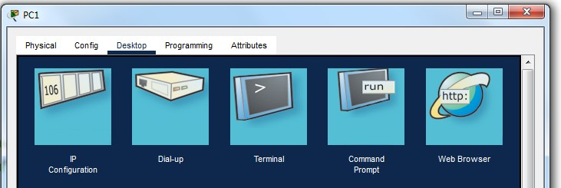

* + 1. In the **“command prompt”**  window type **“arp -a”**
    2. Note what is displayed.

1. On the switch LS1 issue the following commands to see what is stored in the CAM table a. Choose the **CLI** mode
   * 1. Click enter until you see the following prompt: Switch>
     2. Type **“enable”**
     3. Type **“show arp”** what do you see? See pic below for guide
     4. You can investigate the CAM table of the switch by typing **“show mac address-table"**. what do you see?

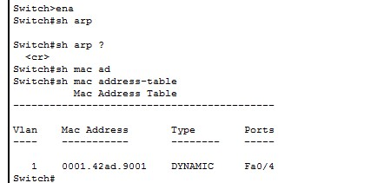

* + 1. Whose MAC address could this be?
    2. Before you leave the switch type the following commands to make sure it stays in the privileged mode of operation. See pic below for commands and steps.

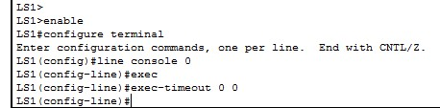

1. Similarly if you want to see the packets flowing in the network then follow these steps or jump to 6 if you are not interested.
2. If want to observe the flow of data in PT between LAN_PC1 and LAN_2 follow the commands below or jump to step 7.
   1. Switch to **Simulation Mode** in the bottom right-hand corner.
   2. Click **Edit Filter** in the **Edit List Filter** area. In the event list filter, *only select* **ARP** and **ICMP** filters under IPv4 tab, desect all other filters in the three tabs **IPV4, IPV6** and **Misc**.
   3. Select a **Simple PDU** by clicking the **closed envelope** in the upper toolbar.

With the envelop icon, click **LAN_PC2** to establish the source. Click **LAN_PC1** to establish the destination.

1. Using the IP addresses you have configured previously, ping LAN_PC1 from LAN_PC2.

**Note that if you have carried out step 6 above you do NOT need to do part (a) below.**

* 1. Click on LAN_PC2 and from the Desktop link choose the Command Prompt and type the following command when you see the prompt C:\>**“ping (put the IP address of LAN_PC1 here)”** and you should see something similar to the pic below

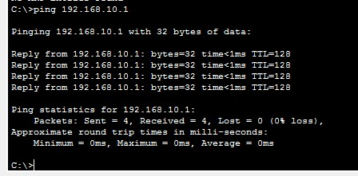

* 1. Repeat steps 3 and 4 above to see if any of the tables have changed.
  2. What did you observe? Explain it in your own words.

Now there’s an arp table because we successfully pinged the other pc. In this case it records the ip address, and also the mac address.

* 1. What happens to the CAM table in LS1 if you don’t do anything for a period of time?

1. Using the IP addresses you have configured previously, ping from LAN_PC2 ping all of the other PCs including the server.
   1. Click on LAN_PC2 and from the Desktop Command Prompt type **“ping (put the IP address of LAN_PC3 here)”**

**Does**, bcs its all in the same network and we don’t need to set up any static ip route

* 1. Click on LAN_PC2 and from the Desktop Command Prompt type **“ping (put the IP address of R1 interface connected to the switch)”**. Was the ping successful? Explain why or why not.

**Does**, bcs its all in the same network and we don’t need to set up any static ip route

* 1. Click on LAN_PC2 and from the Desktop Command Prompt type **“ping (put the IP address of LAN_PC4 here)”** Was the ping successful? Explain why or why not.

Doesn’t work, bcs haven’t set up def gateway ( static ip route )

* 1. Click on LAN_PC2 and from the Desktop Command Prompt type **“ping (put the IP address of the Server here)”** Was the ping successful? Explain why or why not.

Doesn’t work, bcs haven’t set up def gateway ( static ip route )

* 1. Repeat steps 3 and 4 above to see if any of the tables have changed.
  2. What did you observe? Explain it in your own words.

Arp table updates the table with ip and mac add when a ping is succesfull

*~~~~~ End of Lab ~~~~~*